WEEK 2

MongoDB Queries Screenshots 🡪

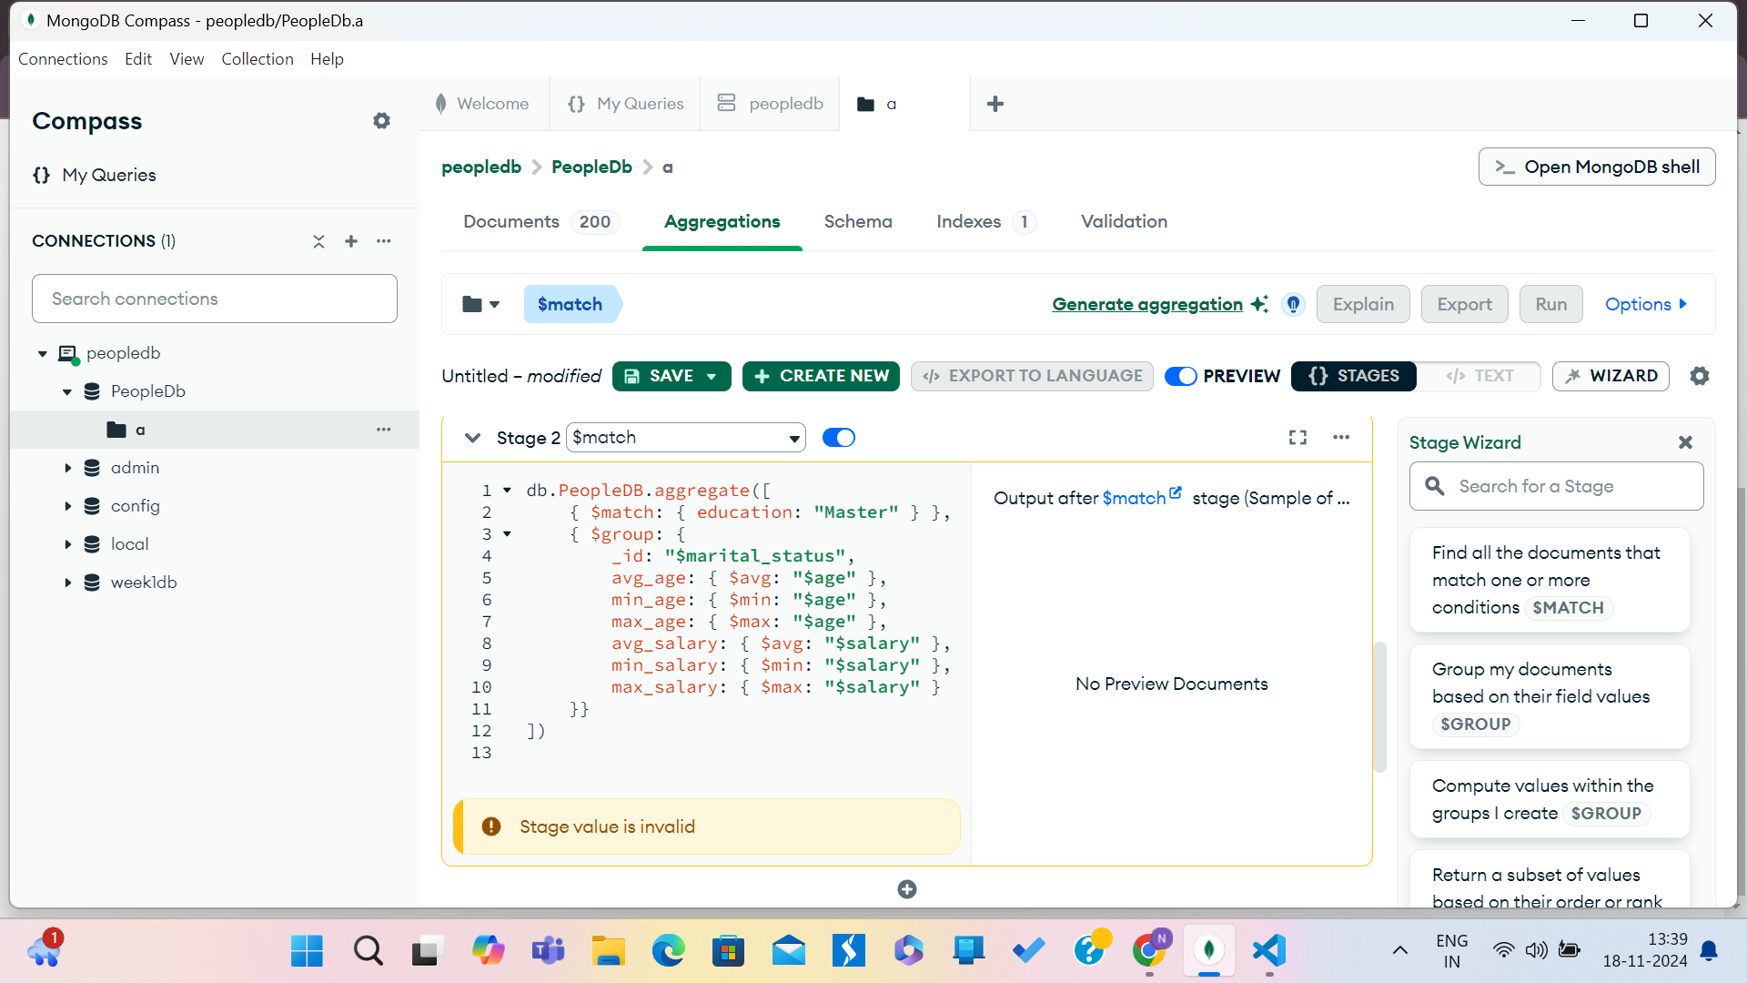

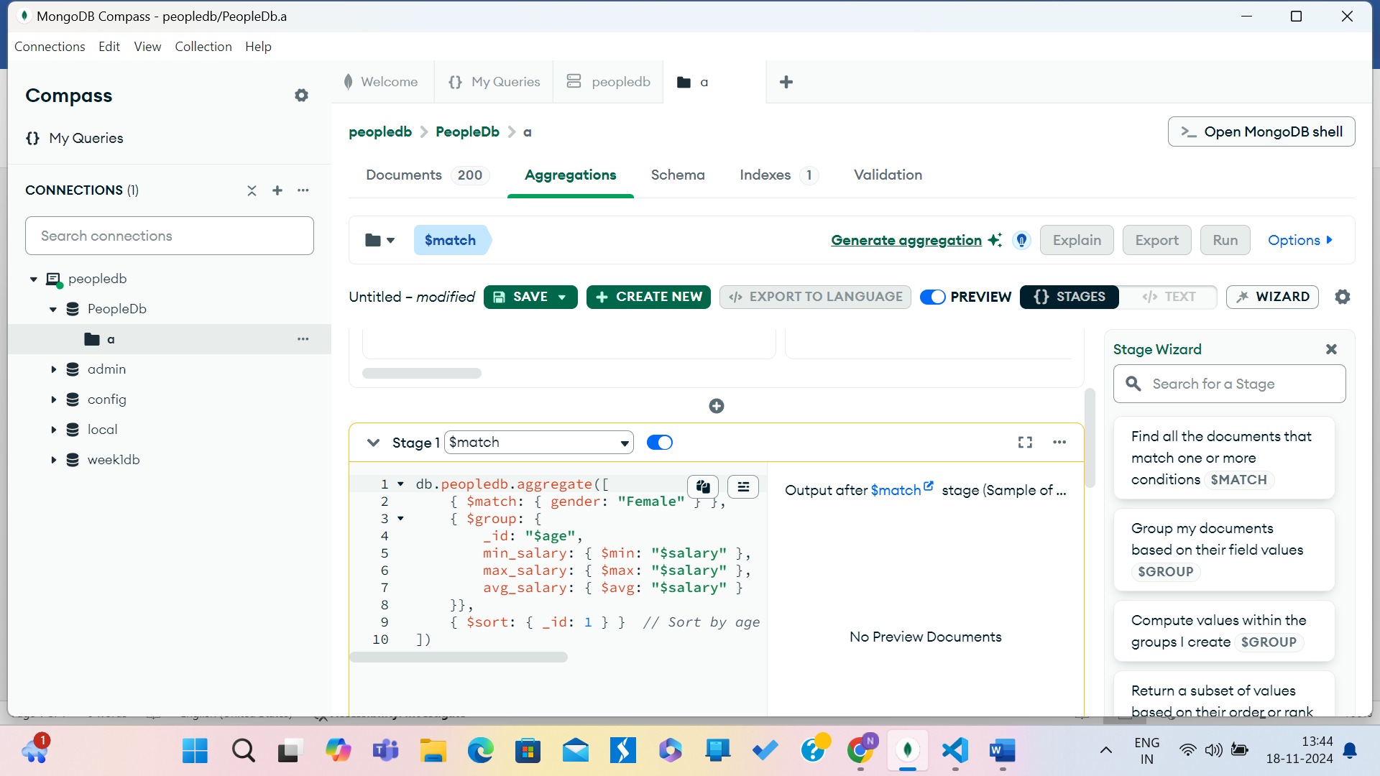

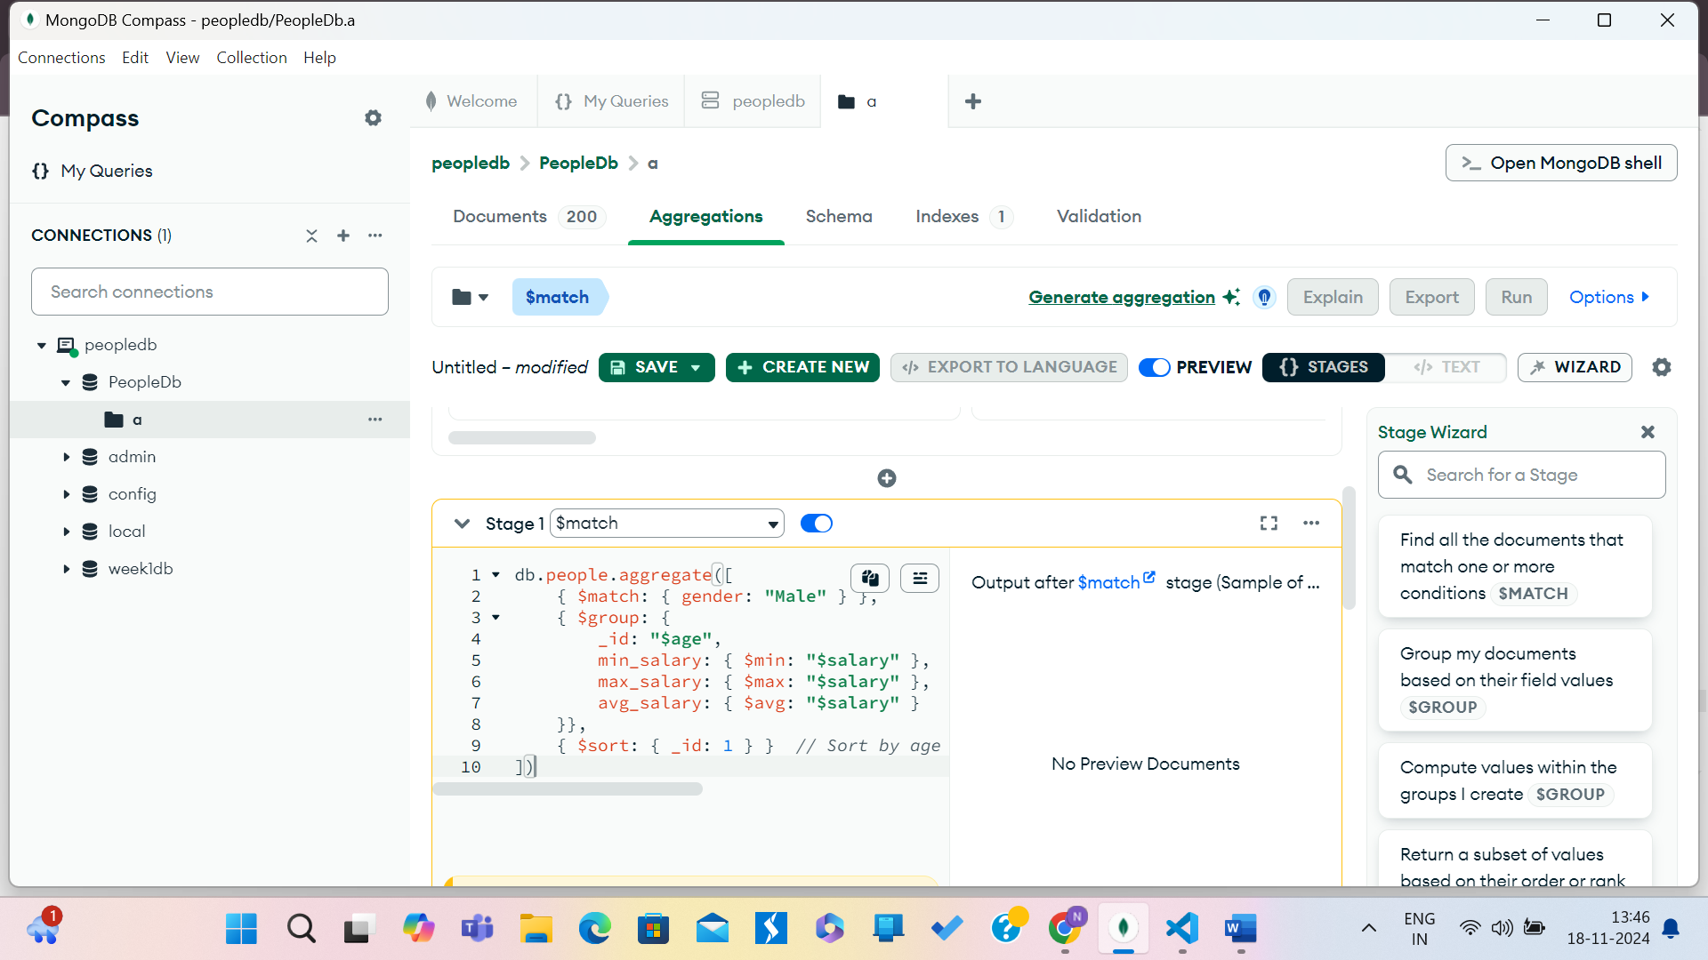

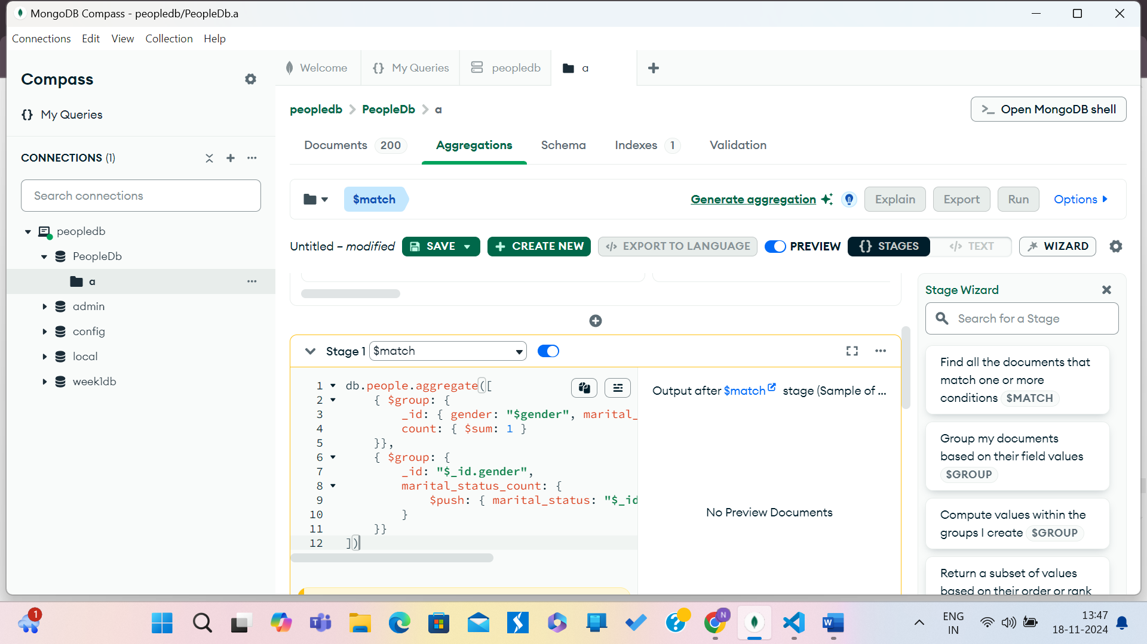

**Reflection for week 2 lab**

**Overview:**

In today’s lab, I worked with MongoDB queries to analyze data. I focused on calculating average, minimum, and maximum values for age and salary, and performing group-based aggregations based on marital status and gender using MongoDB’s aggregation framework.

**Tasks Completed:**

Master’s Degree Search: Created a query to find people with a Master’s degree and calculate average, min, and max age and salary, grouped by marital status.

Salary Analysis by Gender and Age: Calculated salary statistics (min, max, avg) for each age group of females and males.

Counting Married and Unmarried: Counted the number of married and unmarried males and females by gender.

**Key Learnings:**

Aggregation Pipeline: I learned to use $match, $group, and $sort stages to group data and calculate statistics.

Gender and Marital Status: The task of counting married/unmarried individuals helped me understand nested grouping and the $push operator.

Troubleshooting: I gained experience in debugging MongoDB queries, especially dealing with syntax and grouping issues.

**Reflection:**

This lab helped me understand how to use MongoDB’s aggregation framework to analyze data effectively. I feel more confident in creating complex queries and aggregations. I plan to explore more advanced aggregation techniques as I continue learning.

**Conclusion:**

This session improved my MongoDB skills, especially in using the aggregation framework for data analysis. I'm excited to apply these skills in future projects.